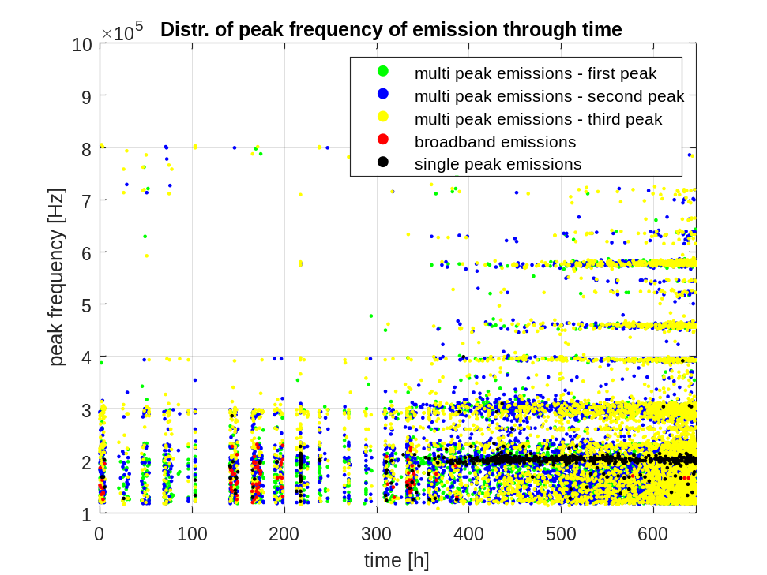
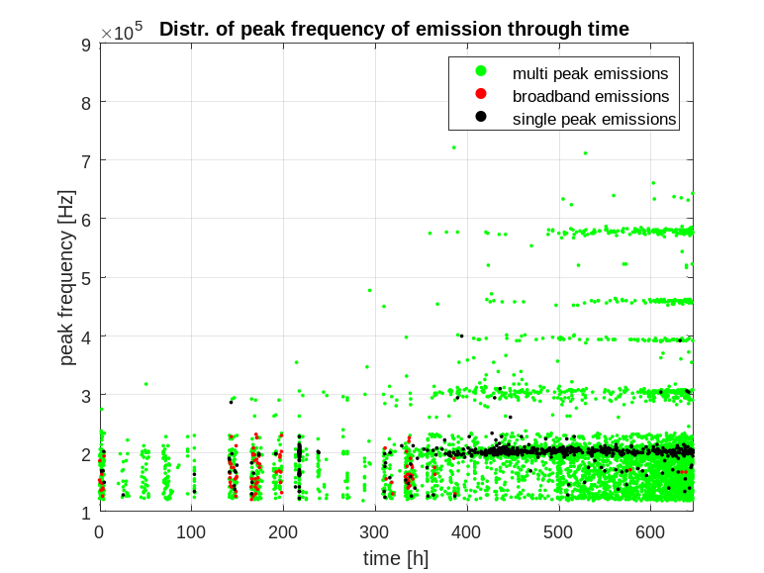
Total number of emissions: 6473
emissions / events: 6473 / 17073 = 37.9137%
LF interferences / events: 8792 / 17073 = 51.4965%
HF interferences / events: 2421 / 17073 = 14.1803%
broadband emissions / emissions: 104/6473 = 1.6067%
single-component emissions / emissions: 611/6473 = 9.4392%
multi-component emissions / emissions: 5758/6473 = 88.9541%
single-component emissions between 175 kHz and 250 kHz: 535/611

